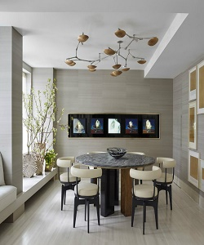

Modern Dining table

$150.32

Availability: In stock

Description

Delightful modern dining table with 6 white stylish chairs and a round marble base table with 3 wood legs to ensure support. Embrace mid-century modern design with this retro dining table that brings clean lines and natural tone wood and marble together into one cohesive design. A simple, round tabletop sites atop a marble base with wood legs.